**Assignment-2 (OSCN)**

**Enrolment ID: 2503B05101**

**Name: Kassim Sesay**

**Question:**

Simulation of **Distance Vector Routing** using the **Bellman-Ford Algorithm** in C++.

Enter the number of nodes: 4

Enter the cost matrix (Enter 100 for INF):

0 2 5 1

2 0 3 2

5 3 0 3

1 2 3 0

**Code:**

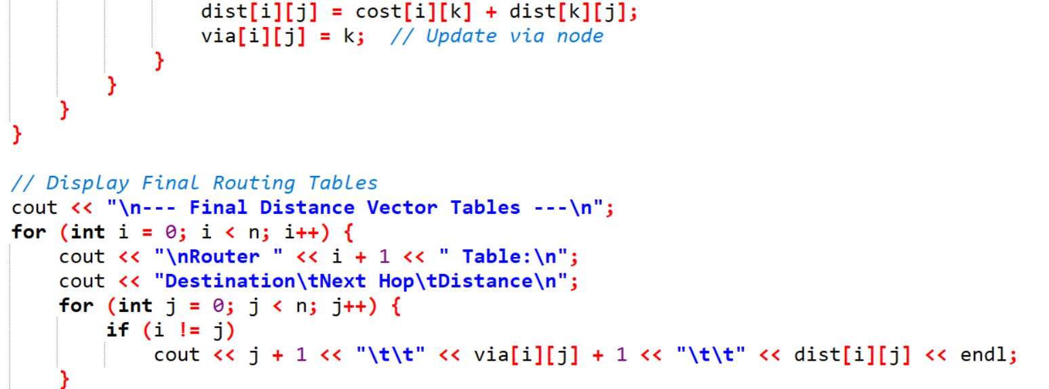

**Output:**

